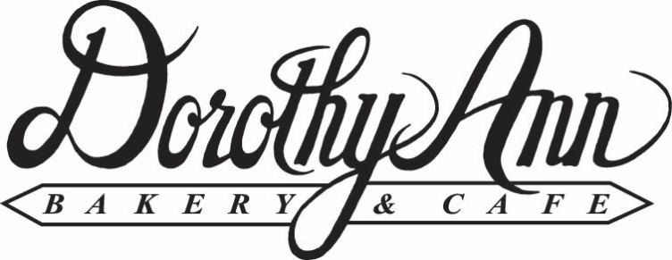
710 Commerce Drive Suite 100
Woodbury, MN 55125
651-731-3323
www.dorothyannbakery.com
Box Lunch Menu
Classic Bag Lunch: Includes Turkey or Ham Sandwich, Chips, Cookie, Pickle Spear and * Condiment bag
$9.99
Premium Bag Lunch: Includes Wrap or Premium Sandwich, Chips, Cookie, Pickle Spear and * Condiment bag
$10.49
DAB Classic Box Lunch: Includes Turkey or Ham Sandwich, Chips, Fruit, Brownie, Pickle Spear and * Condiment bag
$11.99
DAB Premium Box Lunch: Includes Wrap or Premium Sandwich, Chips, Brownie, Fruit, Pickle Spear and * Condiment bag
$12.49
Salad Bag Lunch: Includes Entrée Size Salad, Dressing, Brownie, Vienna Roll with butter, and silverware.
$10.95
- Condiment bag includes Salt, Pepper, Mayo, Mustard, Napkin, and Knife/Fork

